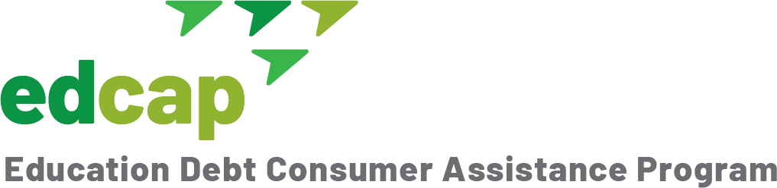

Public Service Loan Forgiveness (PSLF)
Temporary Program Relief—Act Now
The federal government is temporality waiving certain key program requirements until October 31, 2022. Borrowers may now be eligible for forgiveness or have additional payments counted toward the 120 required. If you have questions or need help, contact our Education Debt Consumer Assistance Program (EDCAP) for free one-on-one counseling services at 888-614-5004 (M-F) or edcap@cssny.org.
What’s changing?
- All types of federal loans will qualify for forgiveness. Previously, only Direct Loans qualified for PSLF. You may now get credit for payments made on FFEL and Perkins Loans.
- Payments made under any repayment plan will qualify for forgiveness. Before, you had to be enrolled in an Income-Driven-Repayment (IDR) plan for a payment to count.
- Active-Duty Military will get credit for suspended payments in periods of deferment or forbearance.
What should you do?
- Update your contact information: Make sure your loan servicer and Federal Student Aid (FSA) have updated information. Click here to update your FSA information. If you don’t have an account, establish one.
- Verify your employer qualifies: Log into the FSA PSLF Help Tool using your FSA ID. You will need your employer’s Employer ID Number (EIN). You can find this on your W-2 or by asking your HR department.
- Verify your loan types: Log into your Federal Student Aid (FSA) account at studentaid.gov and click “View Details” to determine the type of loans you have. See next section.
Actions you may need to take by October 31, 2022, to benefit from the waiver:
- If you have FFEL or Perkins Loans: You will need to submit a Direct Consolidation Loan (DCL) Application and PSLF Certification Form(s). Submit the DCL first and the PSLF Certification Form(s) after the DCL has been completed.
- If you have Direct Loans but have never submitted a PSLF Certification Form:
  - If your loans are at FedLoan, submit a PSLF Certification Form for each employer you’ve had over the period you want reviewed.
  - If your loans are not at FedLoan, contact EDCAP for guidance.
- If you have Direct Loans and have submitted PSLF Certification Forms: Your loans should be reviewed automatically to see if you have additional qualifying payments. Submit additional Certification Forms to update your qualifying payment count if necessary.
Need more information? For more details on this relief see the DOE PSLF Fact Sheet and the FSA PSLF Limited Waiver Opportunity webpage. We will update our information as it becomes available.
Need help? Contact EDCAP! All our services are free!

EDCAP (edcapny.org) is a program initiative of the Community Service Society of New York

