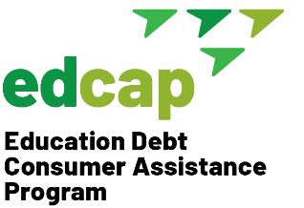
Education Debt Consumer
Assistance Program (EDCAP)
633 Third Avenue, Floor 10
New York, NY 10017
T: (888) 614-5004
E: edcap@cssny.org
Web: edcapny.org

EDCAP: Recommended Bookmarks for Counselors: 12.14.21
- FSA Home Page
Access to general info from studentaid.gov site

- FSA Login
Easy access to client login

- FSA Loan Simulator
Payment plan scenarios and options

- FSA Forms Library
Access PDFs and online filing

- PSLF Certification & Application Form
Employment Certification for PSLF. Must be filed to get official qualifying payment count.

- PSLF Help Tool
Verify employer eligibility for PSLF and auto-populate PSLF Certification Form. Note: must still be printed, signed by borrower & employer and sent to FedLoan or future PSLF servicer(s).

- Consolidation Application
File Consolidation Application Online

- IDR Application
File IDR Application Online (New Applicant, Recertification, Recalculation, Switch Plans)

- Federal Student Loan Servicer Contact Info
Loan Servicer phone numbers

- FSA Feedback Center (For Complaints)
File a complaint with U.S. Department of Education’s Ombudsman’s Group

- NYS Department of Finance Complaint Portal
File a complaint with New York State

- MyFedLoan Account Login
Check PSLF Qualifying/Eligible payment count

- Make Lemonade
Loan calculator

